UDC: 339.9
Nechitaev V.A.
vov.bob2011@gmail.com,
Evtushenko V. K.
Evtushenko.vlad103@yandex.ru,
Khushtova A.R.
khushtova04@mail.ru,
Russia, Rostov-on-Don
Rostov State Economic University (RINH)
Sagaidachnaya E.N., Candidate of Philological Sciences, Associate Professor – scientific supervisor
Abstract
The article examines the impact of natural disasters on the world economy as a component of its development. The author analyzes the factors of the impact of cataclysms on various segments of the world economy.
Keywords
Economy, natural disasters, demand, pandemic, prices.

The impact of natural disasters on the world economy
To date, meteorological observations are no less important than, in fact, stock exchange data. This fact is not surprising considering the numerous natural disasters that have occurred on Earth in different epochs of human existence. Floods, volcanic eruptions, epidemics, earthquakes, fires, landslides claim many human lives and provoke enormous economic losses. For example, in 2010, earthquakes in Chile, China and Haiti killed more than 225 thousand people. At the same time, the social infrastructure, houses, factories and other necessary objects for life were destroyed, and the world community allocated over $ 10 billion to help Haiti. At the end of February 2010, an equally terrible natural disaster occurred in Western Europe. On the territory of Belgium, Denmark, France, England, Germany and a number of other European countries, cyclone “Xynthia” struck, which claimed the lives of 63 people and caused damage, according to some estimates, equal to 4.1 billion dollars.
But all of the above are local problems that lend themselves to preliminary calculations and do not greatly affect the global economy and financial markets. Consequently, there are other costs that have a much longer-term perspective.
What can the banal, at first glance, consequences of drought in Latin America lead to? The first to be affected by this problem are farmers. Severe drought will lead to low soil fertility, which entails a period of crop failure. Also, such a situation is potentially capable of affecting both Western European acreage and agricultural lands of the Eastern European region (including the territory of the CIS). And as a result, prices for basic agricultural crops may increase significantly. A similar situation was already observed in the fall of 2009, when, against the background of a severe heat wave in Latin America, corn and wheat prices soared by more than 30% in the United States and a number of other countries in a month and a half.
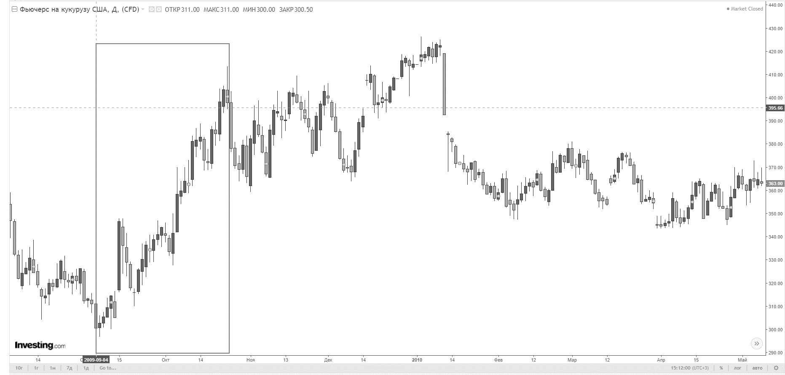
Figure 1. Corn price increase in 2009
Another example is the new coronavirus infection COVID–19, which was first detected in 2019 in Wuhan. So, in the USA in 2020, they predicted a decline in demand for lumber and reduced logging production by 40%. But, oddly enough, in 2021, the demand for wood in North America not only did not decrease, but also increased by 377%. This is due to the fact that during the isolation, US residents massively began to engage in construction, thereby increasing the demand for these products.
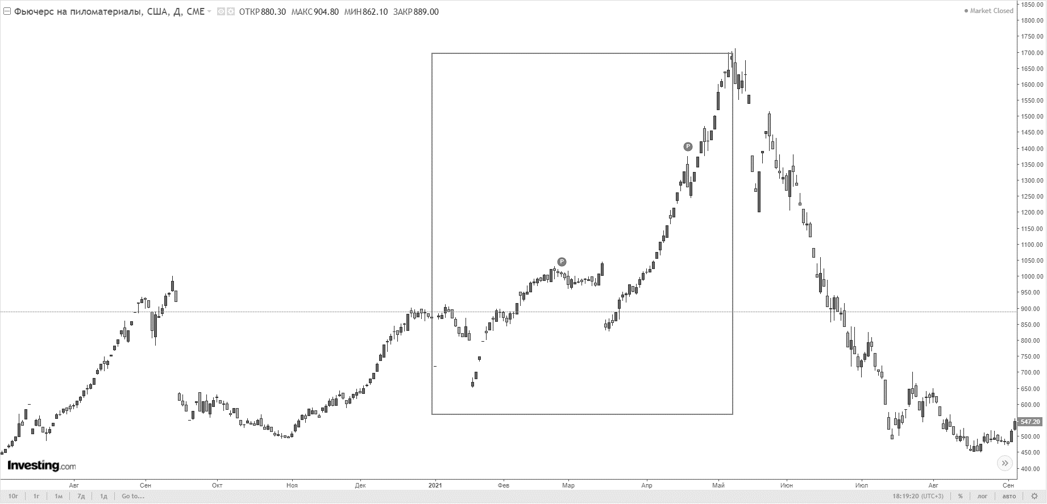
Figure 2. Increase in lumber prices in 2021
However, the coronavirus pandemic is able to change not only the prices of lumber in North America. It is capable of changing industries and behavioral patterns of international companies and consumers. The fear of a pandemic is changing supply and demand in the global economy. The supply was affected by the shutdown of production in China, which reduced global production. At the moment, China's share in the global manufacturing economy is approximately 25%. In 2003, when there was an outbreak of SARS, this figure in China was only 11%. Today, China is a link in global logistics chains. So stopping production in China will reduce economic activity in the world, as well as affect the productivity of other companies in the supply chain.
As for demand, the fear of contracting coronavirus lowered it for certain services. In all countries, the entertainment sector is suffering. People stopped visiting cinemas, restaurants, museums, concerts, etc. The demand for travel also fell. At the same time, online trading is gaining popularity, and the demand for digital computer games in the world increased by 20% in 2021 compared to 2019. People who are at home with their family all the time need something to distract them. The online economy is great for this. This is one of the key differences between the current situation and the times of SARS in 2003. The growth of online shopping has reduced the impact of the pandemic on demand. In general, the effect is still negative, but it is weaker than in 2003. The impact on the demand of a particular company depends on what it sells. Premium brands are suffering. Such goods are often bought in person, and not via the Internet. Since going to a premium store is part of the fun of shopping. However, for ordinary goods, the transition to online shopping can become a long-term trend.
For emerging markets, the effect of coronavirus is to reduce the demand for resources. Reduced demand for raw materials such as metals may recoup losses as production resumes. This "accumulated" demand will support prices in the future.
The overall outcome of the pandemic's impact is likely to be a reduction in global inflation. This is due to the fact that reduced demand for raw materials leads to lower prices for it. Less demand for services will also lead to lower prices for them, at least in the short term. Problems in supply chains, in theory, can raise prices for finished goods. However, manufacturers are usually in no hurry to raise prices for their goods if supply problems are temporary. If a company assumes that a pandemic will cause problems for a month or two, it is unlikely to upset consumers by raising prices for such a short time. When the pandemic begins to subside, as it is now, the fear of coronavirus will also subside. But there are three obvious long-term conclusions.
First: global supply chains have found a weak spot. The development of technology has already pushed production to localization. The factory in Munich, where robots work, replaces the factory in Guangzhou, where people work. This localization process was already going on naturally. And disruption of supply chains, together with uncertainty, can accelerate this process. This means that after the pandemic, investments may begin to grow as supply lines are reconfigured.
The second conclusion: people who had to work remotely may like it. Companies may realize that employees do a great job from home. Changing jobs will affect demand, office real estate, transportation and technology.
The third long—term effect is the growth of online shopping. It has already taken place in most countries of the world. But people who got used to online shopping during the pandemic may just not want to go back to the old way of shopping. It should be understood that economic data may not show this, if statistics underestimate online sales, then consumer spending may seem less than it actually is.
Summing up the above, it should be noted that the world economy is quite sensitive to such a factor as natural disasters. The impact of catastrophes on the world economy in the short term certainly has a negative character, but if we consider some cataclysms in detail and from different sides, we can conclude that in the long term, the impact has practically no negative character.
List of literature:
- The Impact of Natural Disasters on the Global Economy // The One Brief URL: https://theonebrief.com/the-impact-of-natural-disasters-on-the-global-economy/ (дата обращения: 16.04.2022).
- Экономика страха: как коронавирус изменит бизнес и потребителей // Forbes URL: https://www.forbes.ru/biznes/395525-ekonomika-straha-kak-koronavirus-izmenit-biznes-i-potrebiteley (дата обращения: 16.04.2022).
- Оцифрованные: как пандемия повлияла на игровую индустрию // Forbes URL: https://www.forbes.ru/tehnologii/420471-ocifrovannye-kak-pandemiya-povliyala-na-igrovuyu-industriyu (дата обращения: 16.04.2022).
- Как влияют природные катаклизмы на мировую экономику // The Epoch Times URL: https://www.epochtimes.ru/content/view/36219/3/ (дата обращения: 16.04.2022).
- Как стихийные бедствия влияют на мировую экономику // KM.RU URL: https://www.km.ru/biznes-i-finansy/obzory/prirodnye-kataklizmy/10831 (дата обращения: 16.04.2022).
- 5 Natural Disasters That Have Affected the Economy with Billions of Dollars // Interesting Engineering URL: https://interestingengineering.com/5-natural-disasters-that-have-affected-the-economy-with-billions-of-dollars (дата обращения: 16.04.2022).
- The Economic Impact of Natural Disasters // Business Pundit URL: https://www.businesspundit.com/the-economic-impact-of-natural-disasters/ (дата обращения: 16.04.2022).
- How do natural disasters affect the economy? // World Economic Forum URL: https://www.weforum.org/agenda/2015/02/how-do-natural-disasters-affect-the-economy/ (дата обращения: 16.04.2022).
- The Financial Effects of a Natural Disaster // Investopedia URL: https://www.investopedia.com/financial-edge/0311/the-financial-effects-of-a-natural-disaster.aspx (дата обращения: 16.04.2022).
- Stephane Hallegatte The indirect cost of natural disasters and an economic definition of macroeconomic resilience // Finance and Markets Global Practice Group & Global Facility for Disaster Reduction and Recovery. - 2015.07.02
- Порфирьев Б.Н. ЭКОНОМИКА ПРИРОДНЫХ КАТАСТРОФ // Мир новой экономики. - 2015. - №4. - С. 21-40.
- Shturman D.M., Tictin S.A. Economy of disasters. - London: O verseas Publications Interchange Ltd, 1991. - 189 с.

