Economic performance and living standards in the Netherlands

Diana Mitrushina

Date: 18.10.2023

Introduction

Body:

1. GDP by sector
2. GDP Growth annual
3. Unemployment
4. Top 7 exported industries during 2020
5. Destination of Dutch goods imports 2015-2018
6. Net expert
7. GDP per capita
8. GDP, PPP
9. Inflation
10. Social Progress Index

Conclusion

Literature list

**Intro thesis**

Once the Netherlands has begun to be known as an industrialised and developed state with "a vigorous spirit of enterprise" and open economy, in order to strengthen international relations, the state took part in multiple global organisations, for example, the UN International Court of Justice, The European Investment Bank, North Atlantic Treaty Organisation and many others related to the process of cooperation within Europe (Government of the Netherlands ND).

At the beginning of the 21st century, the state turned into a middle-sized member of the European Union (Rood 2003).

All these measures mentioned above (financing, developing assistance, agreements on countries' contribution, helping unstable regions near Europe) were taken in order to have a certain prosperity for many nations by showing sustainable and balanced growth at the same time with "accelerating regional economic integration." (APEC ND, para1).

How did the Netherlands attain these levels of economic growth? The Netherlands is a country with a flexible labour market and somewhat limited dependency on foreign capital, so the situation with structural development was far not the worst in the world (Masselink and Van den Noord 2009).

**Body thesis**

In 2019, based on nominal GDP as just above $907 billion, the Netherlands was ranked the seventeenth-largest economy in the world (Silver 2020). The Netherlands spends a significant proportion of its GDP on the tertiary sector.

Over the past decade, the Gros Domestic Product's growth (annual %) rates (Figure 2) of the Netherlands have fluctuated significantly.

The unemployment rate in the Netherlands increased from 3,66% to 7,43% throughout six years from 2008 to 2014. Like the other countries, the Netherlands economy shrank (SGI 2020). The state felt the consequences of the 2008 economic crisis in the context of a deflationary spiral, which refers to a scarcity of liquid assets for many financial institutions.

Continuing the discussion of exporting goods (Figure 4) to overseas markets, the industry in the Netherlands specialises in the production of high quality and competitive products. The leading industries are machinery, gas, even with its deficiency, oil production and processing industries, metallurgy, chemical industry, electrical engineering, and areas of great importance: shipbuilding, food sectors (Workman 2021).

According to the bar chart (Figure 5), half of the imports is allocated to the national industry or domestic consumption, whereas approximately the same amount is dedicated to re-exports. This term describes the export of previously imported goods into the country for resale to other states.

In December 2020, the Netherlands exported €39.7 billion and imported €35.2 billion, resulting in a €4.52 billion trade surplus, clearly shown in the net exports graph (Figure 6). Between December 2019 and December 2020, the Dutch shipments rose by 1,78%, which is €696 million, from €39 billion to €39.7 billion, but imports decreased by €222 million (-0.63%). The net exports rate starting from the second quartal in 2020 rocketed up by just over 17%, showing the pick at €22,6 million (Creemers, Franssen and Jaarsma 2020).

According to the World Bank and the International Monetary Fund, GDP per capita (Figure 7) in fiscal 2017 and 2018 years was estimated at approximately $ 48,860, making the Netherlands one of the highest-income countries in the world. The GDP per capita and the GDP PPP (Figure 8) levels are slowly but surely growing, reaching about $52,331 and 1,062 trillion current international dollars accordingly in 2019 (The World Bank 2019).

Nevertheless, over the past ten years, the inflation figure has been erratic in the Netherlands (Figure 9). The comparatively unfavourable macroeconomic statistics for the Netherlands in 2013 can be attributed to financial sector assistance. In February, the collapse of banking and insurance company SNS Reaal necessitated a $14billion bailout, creating domestic and EU questions regarding the Dutch banking industry's overall resilience (Government of the Netherlands 2014).

Following this, figure 11 describes the Gini coefficient or index of income inequality in the Netherlands, which is relatively small compared to other countries, as the government implements particular policies that prevent disparity. Income taxes and cash gains decrease inequalities among the working-age population by around 28,5%, so the kingdom somewhat takes eighth place among all countries (United Nations Development Programme 2020).

The Social Progress Index (Figure 10) can stand as one example clearly describing the country's performance based on three measurements, which can also include various subcategories: basic human needs, foundations of well-being and opportunities (Social Progress Imperative 2020).

Netherlands was ranked eleven in the world among 149 other countries, which means that it is an advanced country (Duurzaam-ondernemen.nl 2020).

**Conclusion thesis**

Overall, the acceleration of technological development processes determines the importance of modeling the knowledge economy with a change in lifestyle and quality of well-being, the development of freedoms and opportunities for access to them, since there is an increasing involvement of the population in new forms of consumer, cultural and spiritual behavior and development (The Netherlands Ministry of Foreign Affairs 2020).

This research paper aimed to answer the following question: "Can a country's economic success be directly related to its living standards?" To determine the association between two given variables, the Kingdom of the Netherlands was used as an example. Based on gathered data and taking all of these factors into account, it should come as no surprise that the Dutch people have enough resources for living a decent life, owing to the government's effective economic decision-making. Such a remarkable economic development within society is accomplished by immense strain on the country's students and workers, namely the Netherlands' exceptional economic success is achieved at the expense of people's happiness.

In conclusion, it is evident that The Netherlands economy is prosperous, as shown by the essay's results, which include steady growth in productivity, trade, both exports and imports, a rise in GDP and social benefits, and a dynamic economy that blends innovation, advanced technology, and development. All of these factors combine to make the kingdom one of the wealthiest and most industrialised economies globally.

**Reference list**

**Example**

Aerts, N., Berg, V., Creemers, S., Draper, H., Franssen, L., Jaarsma, M., Lammertsma, A., Notten, T., Peeters, T., Prenen, L., Rooyakkers, J., and Wong, K. F. (2020) *Dutch trade in facts and figures. Exports, investment and employment.* Statistics Netherlands: The Hague

Amadeo, K., Brock, T. (2020) "Market economy, Its Characteristics, Pros, and Cons, With Examples." *The Balance.* 20 August. [Accessed: 04.04.21] Available at: <https://www.thebalance.com/market-economy-characteristics-examples-pros-cons-3305586>

**Appendix (figures)**

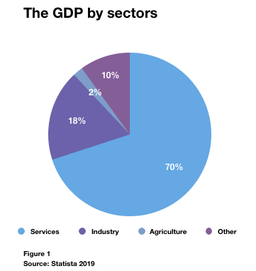

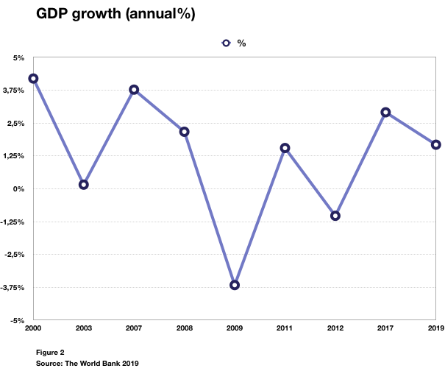

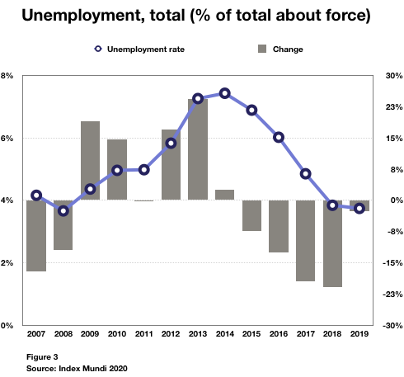

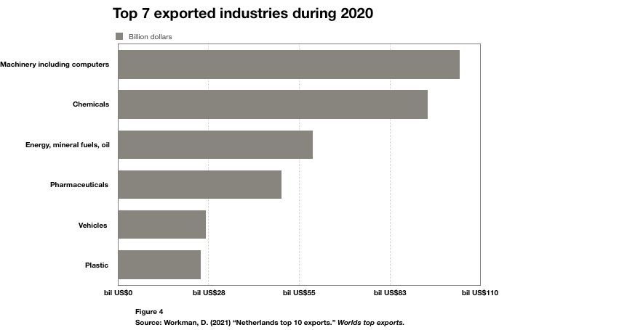

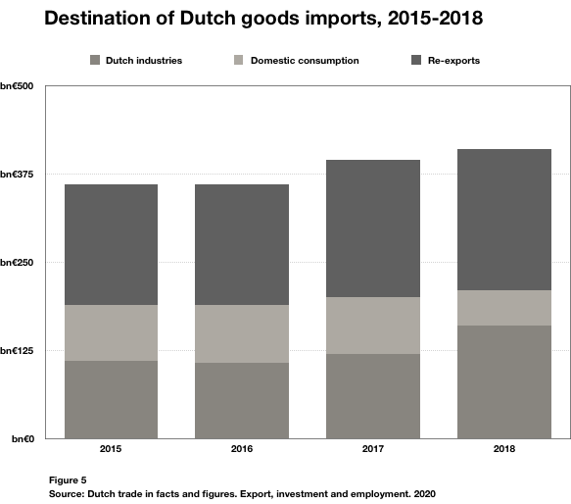

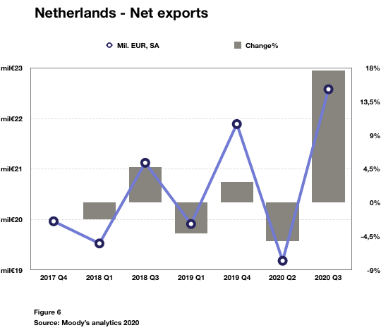

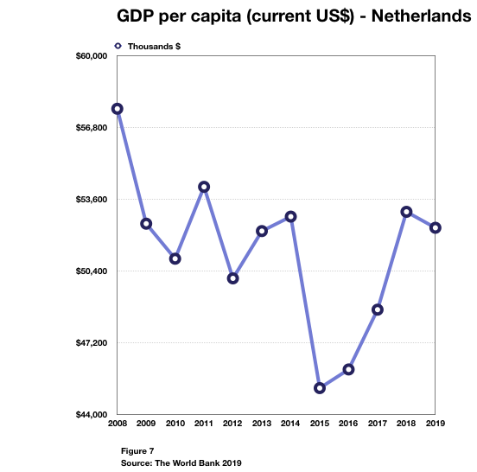

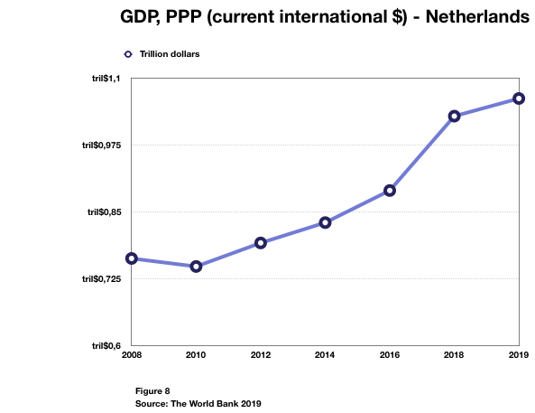

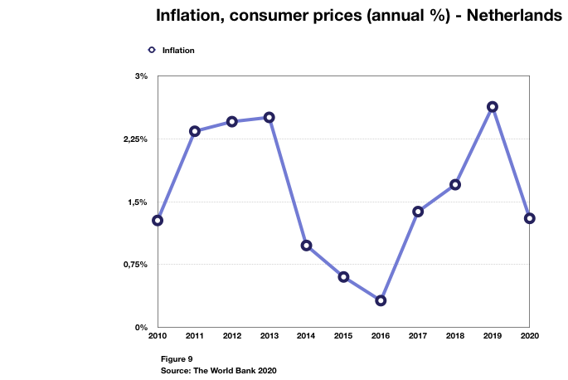

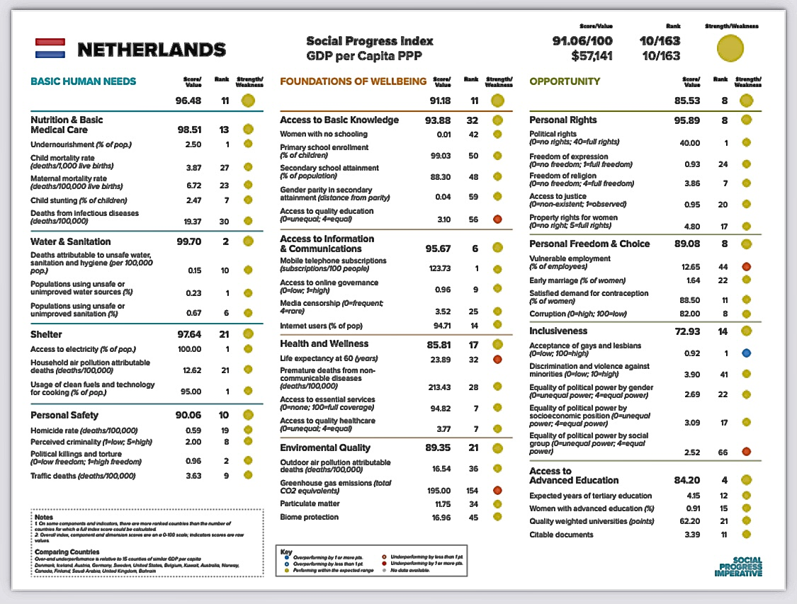

**Figure 10**

**Source: SPI 2020**

